**INDIAN INSTITUTE OF TECHNOLOGY, BOMBAY**



**Department of Aerospace Engineering**

**October 20, 2022**

**AE 725: Air Transportation**

**ASSIGNMENT IV**

**Course Instructor**

*Prof. R. K. Pant*

**Submitted by**

*Team 08*

**PART A - AIRLINE BUSINESS PLAN**

1. **What are the economic drivers you want to serve?**

**Ans:** Nabadwip is a holy tourist and pilgrim place in [West Bengal](https://en.wikivoyage.org/wiki/West_Bengal). It is the birthplace of Chaitanya Mahaprabhu. Many scholars, Sadhakas and Tantriks, were born here. Nabadwip was referred to as the "[Oxford](https://en.wikivoyage.org/wiki/Oxford) of Bengal".  Known for its religious significance, it is home to several sacred temples. The city is primarily a must-visit for those craving a spiritual experience. The Sonar Gouranga Temple, Sri Chaitanya Saraswat Math, and the Dwadash Shiva Temple are famous shrines in and around Nabadwip.

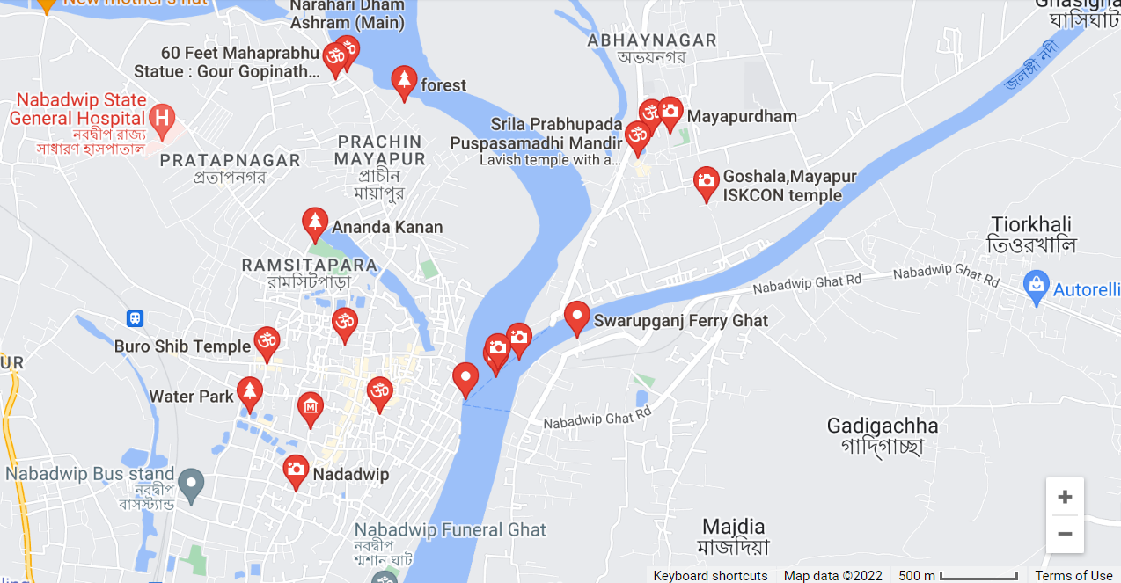

Figure 1: Places of tourist attractions in Nabadwip, Nadia, West Bengal

Along with its devotion, the city also boasts a flair for celebration. A great time to visit Nabadwip and enjoy the local culture is during the festivities of the annual Rash Utsav, celebrated in November, or the Dol Purnima in March. The city, indeed, is at its cultural best during these festivals.

Also, the city has no major restaurants, hotels or industrial setups. **Hence,** **the primary economic driver that we would want to exploit is the city’s tourism value; our primary target segment will be leisure travellers and tourists.**

1. **Based on these factors, do you want to operate a passenger, freight, or mixed service?**

**Ans:** The primary demand for air travel to Nabadwip is most likely to come from the segment of people looking to visit the city for its religious and spiritual significance and the tourists visiting West Bengal in general. There is no primary requirement for freight transportation by air as there are no major industrial setups in the city and, the city is well connected by rail.

**Due to these factors, we would want to operate a passenger service, which would also take care of the nominal freight transportation requirement in its underbelly.**

1. **What type(s) of aircraft do you want to use, and why?**

**Ans:** Selecting the right aircraft is a very important factor for successful airline operations. It is important to consider the following main factors.

1. **A Low-Cost Carrier or A Full-Service Carrier?** While a lower price is one difference, it's not the only difference, and low fares alone don't mean an airline is a low-cost carrier. Many of the differences actually relate to how the airline operates. On low-cost carriers, there is often only one class of service instead of the typical division of economy, [premium economy](https://scottscheapflights.com/glossary/premium-economy), business, and first class. A full-service airline typically offers passengers in-flight entertainment, checked baggage, meals, beverages and comforts such as blankets and pillows and all these services are charged in the ticket price. The most obvious difference between low-cost and full-service carriers is the extra fees low-cost airlines charge for things like in-flight beverages, carry-on bags, or pre-flight seat selection which is optional to a passenger.

**Keeping in mind our aim of providing low-cost affordable quality services to the growing middle-class passengers with relatively less leisure income, we would like to go for a Low-Costs Carrier instead of a Full-Service Carrier.**

1. **Airline Business Model?** As already brought out, our Airlines will aim to serve the segment of people looking to visit the city for its religious and spiritual significance, and the tourists visiting West Bengal in general. That is, **we will be providing scheduled flight services** to fulfil this aim.
2. **Hub and Spoke model or Point to Point model?** Since our airlines will be based out of Nabadwip, West Bengal i.e, we will be providing connectivity to Nabadwip, West Bengal initially from a major airport that is Kolkata and subsequently when demand is realised and confirmed from a business model it will be offered to other parts of the country. **Therefore, initially we would initially like to go for Hub and Spoke model operating between Nabadwip, West Bengal and the established hub of Kolkata Airport.** Accordingly, we will be using small-sized aircraft for all the selected route.
3. **Cost of Operation.** Some engines are expensive to maintain. Total Care is expensive if aircraft utilisation is not high. Among old aircraft, there are some engines more expensive to maintain or overhaul than their new engine models. Also, the poor fuel efficiency of old technology aircraft adversely affects the operating cost of the airlines and in turn badly affects the revenue generation capability. So, **our strategy will be to go for relatively newer aircraft equipped with more fuel-efficient technologies**.
4. **Operational Requirement.** The criteria of Expected number of passengers and selections based on it is important. Not too big, not too small, just the right size. Runway length and other operational conditions of airports involved in the routes should also be considered to avoid any difficulty or payload restrictions. Hence, there is a requirement of carrying out detailed market surveys based on the past historical data keeping in mind the competition from the availability of other modes of transport such as Rail. Once, the passenger demand is calculated, we can easily decide upon the aircraft based on its capacity. **In our case, the passenger demand comes out to be roughly 1400 per day on both sides and hence we will be operating with Q 400 which has a passenger capacity of 74.**
5. **Fleet Commonality and Rationalization.** Fleet commonality can help streamline maintenance procedures. This can save carriers money, as well as allowing their maintenance operations to become more specialized. Commonality also benefits operations when it comes to crew rostering. Fairly uniform fleets can be advantageous, as they can expedite aircraft swaps in the event of maintenance issues. This is especially important at low-cost carriers, where turnaround times are faster. **Due to these reasons we will be operating a fleet of only Q 400 consisting of a total of 02 aircrafts**, to cater for the expected passenger demand on the selected route. As the airport is currently enabled with Day Flying, the maintenance activities will be carried out during Non-flying hours.
6. **Do you want to Procure and/or Lease the aircraft and why?**

**Ans:** This is frequently the main subject. It might be quite difficult to decide whether to buy an aircraft or lease one, but when starting an airline, leasing is usually advised. For a start-up airline, purchasing it can be a significant financial commitment and frequently chews up the money for operations. It is advised to lease an aircraft before buying one unless you have a sizable sum of money to fund the purchase and operation. The reasons are as listed below:

1. If an aircraft turns out to be unsuitable for your operation, a lease permits you to switch to a different type.
2. Many airlines lease before buying their aircraft. The main purpose is to understand the aircraft and whether it is appropriate for their activities. It is a technique for them to make sure the aircraft they intend to purchase is appropriate and lucrative for their needs. Think of it as a free trial before you buy.
3. With the exception of the lease rental deposit, lease payments, and maintenance reserves, the remaining funds can be used to support operations, allowing a start-up airline more time to survive.

A case in point is an UK-based airline which had filed for bankruptcy not long after it began operating. It purchased two B767-200’s aircraft with PW JT9D engines. It is well known that B767-200’s powered by PW JT9D engines have substantial maintenance and overhaul costs. It chose to purchase 2 B767-200’s with PW JT9D engines on a "as is, where is" basis, and it appears that engine maintenance costs were not taken into account. Only one aircraft entered service while the other two did not because of the cost of engine maintenance. Most of its startup money was spent on buying aircraft, forcing it to stop operating just over two months after it began.

In our case, the DOC per passenger is coming out to be less for the case of purchase of aircrafts as compared to leasing them. However, it is based out of model and may prove otherwise as it follows the notion of people. **Therefore, it is more appropriate to initially go for Leasing of aircraft** as we would save capital for the operations and in near future, if we see that the passenger demand is growing or maintaining as per our expected values for the selected route and it turns out to be a profitable margin, **we will purchase the aircrafts in future**.

1. **Which nearby airports do you plan to serve? What is the projected demand for your chosen sectors?**

**Ans:** Our first objective is to find the number of people coming to Nabadwip from different parts of the country. According to the report West Bengal tourism published in 2014, we can see that in April 2014 , 106588 domestic tourists visited Nadia. The total number of domestic tourists who visited West Bengal during that time is 2493448. A total of 4.27% of domestic tourists visited the Nadia district during that time. (Link to be added)

There are two approaches ahead we took in solving the problems.

**The first approach**

Netaji Subhas Chandra Bose is the only major airport in the state of West Bengal. Total passenger traffic in the year 2021-22 is 1.096 crores.

Average Passengers traffic per month = 10960000/12 = 91.33 lakhs

Average Passengers traffic per day = 9133000/30 = 30440

Out of the total passenger traffic in Kolkata, we have assumed that approximately 4.5 % (came from 4.27%) coming from and going to Nadia = 30440 *0.045 = 1370

Assuming a slight extrapolation and taking into account certain variability, let the figure be **1400**

A total passenger flying from Kolkata to Nadia or from Nadia to Kolkata = 1400/2 = **700**

**One way demand is 700 passengers**

**Second Approach**

According to Indian Tourist data 2019, a total of 85657365 domestic tourists visited West Bengal in 2018. Annual growth predicted during that time is 7.5%. So we calculated the number of domestic tourists who visited West Bengal in 2020.

Projected Domestic tourists in 2020 = 85657365 * 1.075 * 1.075 = 98987792.43

An assumption in our calculation that projected domestic tourists in 2022 = Projected domestic tourists in 2020 (Considering covid effects)

Domestic tourists visited Nadia district in the year 2022= 98987792.43 * 0.0427 = 4231454.123

Domestic tourists visited per month in 2022 = 4231454.123 / 12 = 352621.1769

Domestic tourists visited Nadia per day in 2022 = 352621.1769 / 30 = 11754.03923

From here it was difficult to find the share of the population from each mode travelled to Nadia

1. Train
2. Bus
3. Personal Vehicle
4. Cabs
5. Flight to Kolkata and bus, train and cabs to Nadia

If the information of a,b,c, and d is available, we can just find people coming to Nadia through flights.

**But since the data is lacking in the second approach, we will be taking the first approach.**

Since we need to plan only for 700 passengers we will be operating from Kolkata to Nadia and 700 passengers from Nadia to Kolkata. It will be the hub and spoke network.

It is known that the influence of Chaitanya Mahaprabhu is in Orrisa, Manipur, Delhi, Maharashtra and Gujarat. However pointing out the exact no, of people devoted and ready to travel by air to Nabadwip from their respective home town is difficult to assume and dedicated a direct flight from all these locations will not be a viable option in the initial setting up of airlines. Therefore we have planned that flights from these states will come to Kolkata and they will change the flight to go to Nabadwip airport.

Since the demand is for small number of passengers (700/ day/route) we have gone for hub and spoke network. For a small demand running a small aircraft for a long distance is not feasible.

1. **What will be the frequency of service (number of departures per day) to these airports?**

**Ans:** Our aim is to cater for a passenger demand of roughly 1400 passengers per day on the Kolkata-Nabadwip route, which includes the traffic from both sides. That is, we have to cater for the air travel of roughly 700 passengers from Kolkata to Nabadwip and the remaining 700 passengers from Nabadwip to Kolkata. This comes down to roughly 10 aircraft loads on both sides. So, we have to provide 10 departures per day from Kolkata to Nabadwip and 10 departures from Nabadwip to Kolkata to cater for the expected passenger demand.

Also, there are three additional points to be kept in mind while scheduling the flights, which are as given below:

1. The time taken by rail/ road travel between Kolkata airport and Nabadwip is approximately 3 hours. Our aim should be to schedule the flights in such a manner that the passengers arriving at the **Kolkata airport can reach Nabadwip in less than 3 hours from the time of their arrival using our flights.**
2. The Airport being constructed at Nabadwip is not yet equipped with night flying facilities. This means that we can **operate the flights only between first light and last light from the Nabadwip airport.**
3. Our aim is to do the flight scheduling in such a way that the aircrafts night parking is done at the Nabadwip airport and not at the Kolkata airport **to avoid the high parking costs at the Kolkata airport.**

Keeping all the above points in mind and considering the block time of 40 minutes and turnaround time of 30 minutes, the proposed flight scheduling is as given below:

**Table 1: Scheduling time of aircraft between Nabadwip and Kolkata**

|  |  |  |  |  |  |  |
| --- | --- | --- | --- | --- | --- | --- |
| S/No. | Nabadwip to Kolkata | | | Kolkata to Nabadwip | | |
| Departure | Arrival | Flight No. | Departure | Arrival | Flight No. |
| 1 | 0600 Hrs | 0640 Hrs | 1 | 0710 Hrs | 0750 Hrs | 1 |
| 2 | 0700 Hrs | 0740 Hrs | 2 | 0810 Hrs | 0850 Hrs | 2 |
| 3 | 0820 Hrs | 0900 Hrs | 1 | 0930 Hrs | 1010 Hrs | 1 |
| 4 | 0920 Hrs | 1000 Hrs | 2 | 1030 Hrs | 1110 Hrs | 2 |
| 5 | 1040 Hrs | 1120 Hrs | 1 | 1150 Hrs | 1230 Hrs | 1 |
| 6 | 1140 Hrs | 1220 Hrs | 2 | 1250 Hrs | 1330 Hrs | 2 |
| 7 | 1300 Hrs | 1340 Hrs | 1 | 1410 Hrs | 1450 Hrs | 1 |
| 8 | 1400 Hrs | 1440 Hrs | 2 | 1520 Hrs | 1600 Hrs | 2 |
| 9 | 1520 Hrs | 1600 Hrs | 1 | 1630 Hrs | 1710 Hrs | 1 |
| 10 | 1630 Hrs | 1710 Hrs | 2 | 1740 Hrs | 1820 Hrs | 2 |

Hence, keeping the requirement, capacity, and constraints in mind, we will be able to provide a total of 20 flights per day which will include 10 flights from Nabadwip to Kolkata and 10 flights from Kolkata to Nabadwip, with a total of 02 aircrafts.

1. **What is your expected operating cost? What Fare will you charge to make a profit?**

**Ans:**

<https://theflyingengineer.com/aircraft/proud-to-fly-a-turboprop-q400-vs-atr72/>For 62 minutes of flying time, there is a fuel burn of 1200 kg

For our 40 minutes flying time block fuel = (1200/62) * 40 = 775 kgs

Stage Length for 136km = 73.4341 nautical miles

We have referred to Assignment 2 for all the values of constants.

The working calculations for Direct Operating Costs are given in the link below.

<https://iitbacin-my.sharepoint.com/:x:/g/personal/22d0271_iitb_ac_in/EXPpIcvwlWBGrfFCAwHl9a0BF7Vms0ANU4ZVrGqCmuCSpA?e=q2VBtD>

**The fare we will be charging is 2392 rupees per passenger.**

**8. Suggest an innovative name, motto, and logo for your airline**

The innovative name for the airline that we would be operating is “STELLAR AIRLINES”

The motto is “Travel with Comfort.”

The logo would be

As it is a new airline and ta ride in the profitability waters, we would give certain lucrative offers and privileges to customers who would be availing our flight. Some of the packages include.

* SWAP SEATS

In this passenger can swap seats on the same day with another flight operated by our airline, paying the difference of the desired flight pursued at that time without paying any Re Scheduling fees.

* COMPLIMENTARY CLOAKROOM

Thus, facility can be availed by those who have booked a return flight on same day and can utilize Free of Charge Cloak Room facilities at Nabadwip airport.

**PART B: - AIRPORT LAYOUT AND AIRCRAFT SELECTION**

1. **Provide the GPS pin (from Google Maps) where you want to locate the airport. If there is an existing airstrip in the location, feel free to reuse the same location (only if there is enough space to operate a commercial airport). Otherwise, you must identify a fresh location.**

**Ans:**

Nabadwip has no existing airstrip that can be used to construct the airport. Based on the availability of space three locations are available.

Location 1: To the East of Rudrapara P

        Coordinates: 23.439254, 88.382419

Location 2: To the South-East of Chupi

        Coordinates: 23.451704, 88.362069

Location 3: To the West of Bhaluka

                    Coordinates : 23.348564, 88.377850

|  |  |
| --- | --- |
|  |  |

Location 1

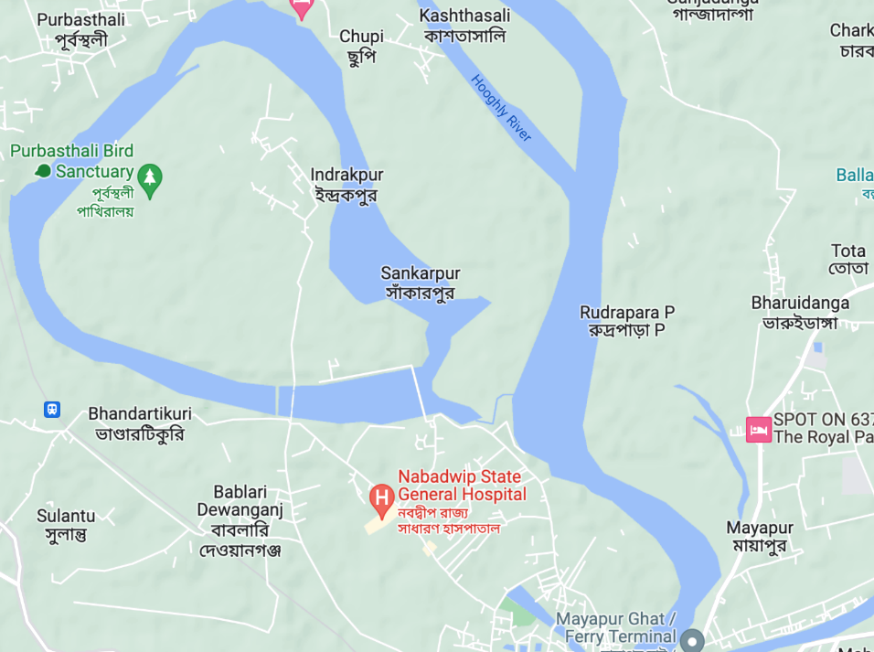

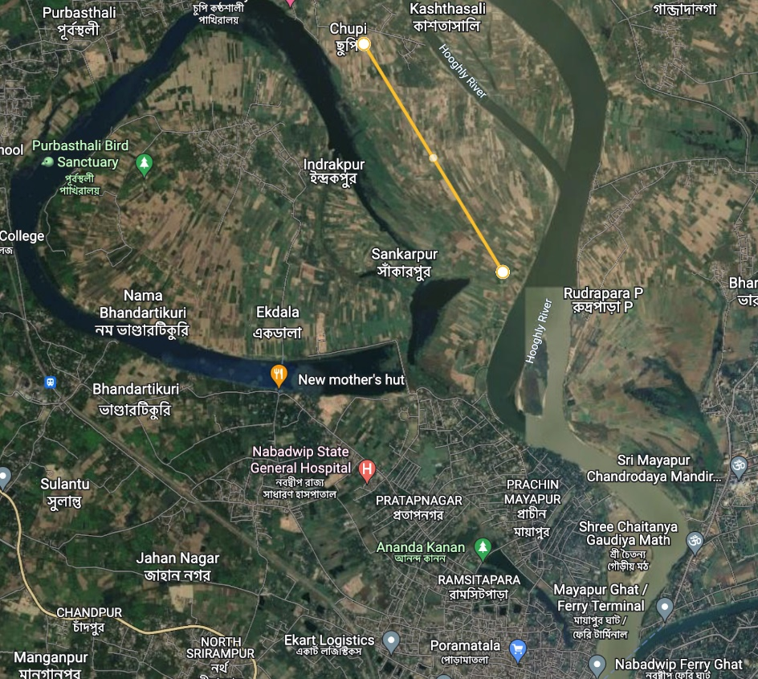

Location 2

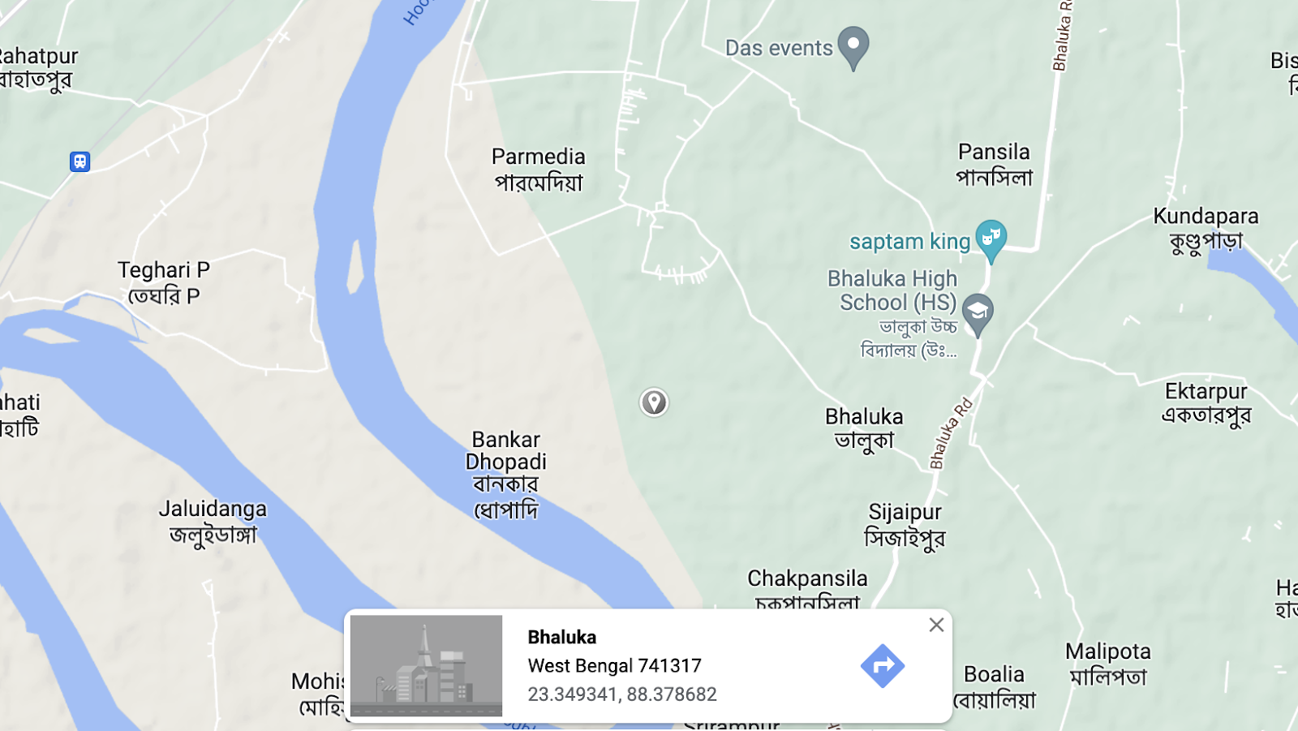

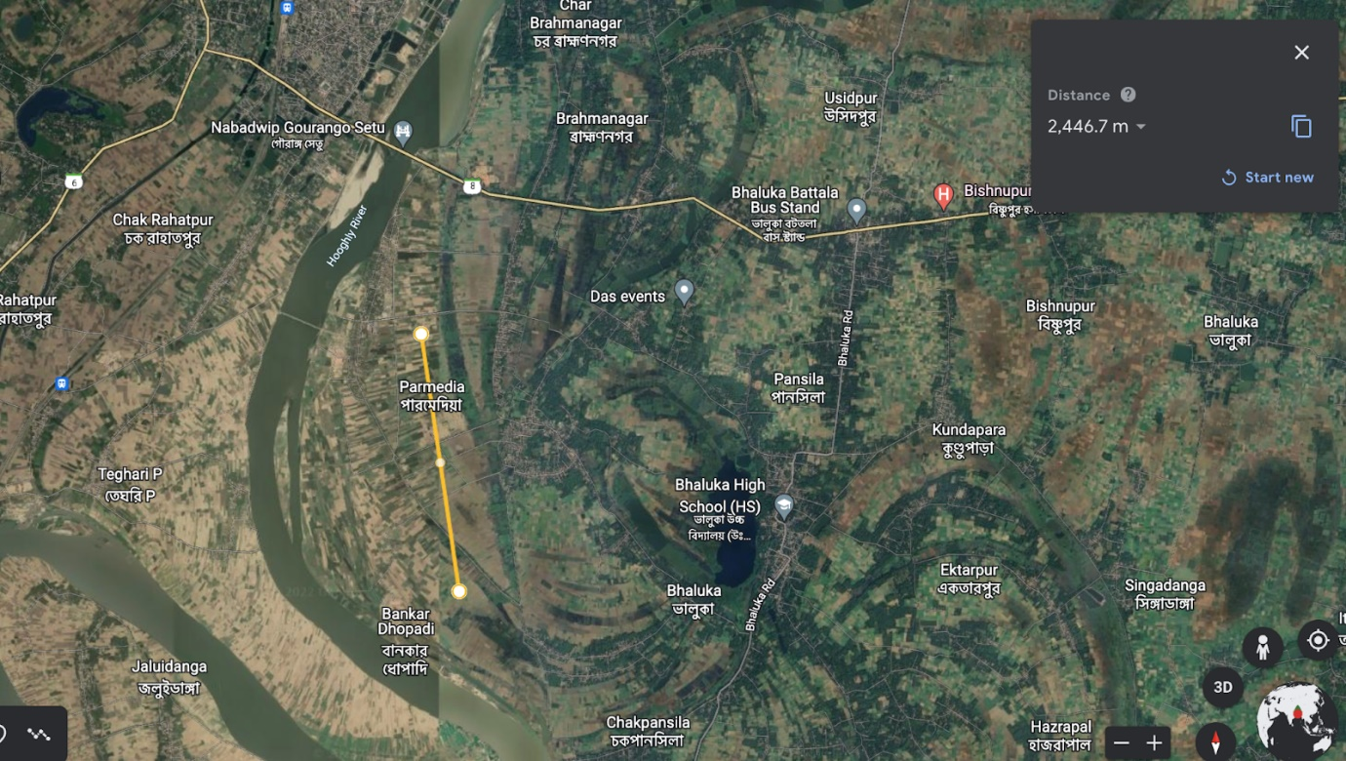

Location 3

**2.  Arrive at an estimate for the likely air travel demand to-and-fro your airport.**

Ans:

Nabadwip is regarded as a holy place by Hindus, and is famous for Rass festival where city is enlited with lights, dieties of God and goddesses are made on each corner of Nabadwip town. Hundreds of people gather to this small town on the occasion of raas utsab. The primary demand for air travel is for the tourist and in such there is no major major freight requirement. So, in such we need to operate a passenger service. Now, lets boil down to the demand.Must visit places are - Sonar Gouranga temple, Sri Chaitanya Saraswat Math, Dwadas Shib Mandir, ISKCON Temple and also Mayapur. Basically, we can empirically calculate the demand. According to a report around 6000 foreign devotees from 50 countries and 4000 Indian devotees are expected to take part in the centenary celebrations of the eight-day ‘Nabadwip Mandal Parikrama’ in February. Though major chunk of demand is seasonal but still there is tourist demand throughout the year. Nearest airport from Nawadbip is Netaji Subahs Chandra Airport (CCU), Kolkata. To find out the total demand, As we know the major airport is Kolkata airport in West Bengal. According to the report West Bengal tourism published in 2014, we can see that in April 2014 , 106588 domestic tourists visited Nadia The total number of domestic tourists who visited West Bengal during that time is 2493448. A total of 4.27% of domestic tourists visited the Nadia district during that time. (Link to be added)

Netaji Subhas Chandra Bose is the only major airport in the state of West Bengal. Total passenger traffic in the year 2021-22 is 1.096 crores.

Average Passengers traffic per month = 10960000/12 = 91.33 lakhs

Average Passengers traffic per day = 9133000/30 = 30440

Out of the total passenger traffic in Kolkata, we have assumed that approximately 4.5 % (came from 4.27%) coming from and going to Nadia = 30440 *0.045 = 1370

Assuming a slight extrapolation and taking into account certain variability, let the figure be **1400**

A total passenger flying from Kolkata to Nadia or from Nadia to Kolkata = 1400/2 = **700**

**One way demand is 700 passengers**

Since the demand we have arrived is 700 which is very less so we have gone for only catering to Kolkata and Nabadwip. Since we need to plan only for 700 passengers we will be operating from Kolkata to Nadia and 700 passengers from Nadia to Kolkata. It will be the hub and spoke network.

**3. Based on this demand, select the aircraft(s) that your airline should operate ?**

Ans

Our aim should be to provide low-cost affordable quality services to the growing middle-class passengers with relatively less leisure income so we would like to go for a Low-Costs Carrier instead of a Full-Service Carrier**.** Our strategy will also be to go for relatively newer aircraft equipped with more fuel-efficient technologies. . In our case, the passenger demand comes out to be roughly 1400 per day on both sides and hence we will be operating with Q 400 which has a passenger capacity of 74.Fleet commonality can help streamline maintenance procedures. This can save carriers money, as well as allowing their maintenance operations to become more specialized. Commonality also benefits operations when it comes to crew rostering. Fairly uniform fleets can be advantageous, as they can expedite aircraft swaps in the event of maintenance issues. This is especially important at low-cost carriers, where turnaround times are faster. **Due to these reasons we will be operating a fleet of only Q 400 consisting of a total of 02 aircrafts**, to cater for the expected passenger demand on the selected route.

5. **Following ICAO regulations, obtain the dimensions of Runway(s), and arrive at layout of the airport components, based on the demand, obstacles in the vicinity of the location.**

Ans:

6.  **Identify two airports nearby that can act as alternate landing ports in case of emergencies. Check for suitability for the types of aircraft you propose to fly and reserve fuel requirements for the same.**

Ans:

The closest airports to Nabadwip are Netaji Subhas Chandra Airport (CCU) at a distance of 85.1km and Jessore Airport in Jessore, Bangladesh at a distance of 85.7km. As it might be difficult to get permission to land in Bangladesh, we will choose the second emergency landing airport as Kazi Nazrul Islam Airport which is at a distance of 130km from Nabadwip. Netaji Subhash Chandra Bose International Airport (IATA: CCU, ICAO: VECC) is an international airport located in Kolkata, West Bengal, India, serving the Kolkata Metropolitan Area and is the aviation hub for the entire eastern and northeastern India. The airport has two parallel runways, The primary runway 01R/19L has a capacity of 35 flights per hour and the secondary runway 01L/19R has a capacity of 15 flights per hour. The secondary runway is used as a taxiway and the main runway is mainly used. When the primary runway is shut down for maintenance, the secondary runway is used.

|  |  |  |  |
| --- | --- | --- | --- |
| **Runway Number** | **Length** | **Width** | **Approach Lights/ILS** |
| 01L/19R | 3,270 m (10,730 ft) | 46 m (151 ft) | CAT I / CAT II |
| 01R/19L | 3,633 m (11,919 ft) | 46 m (151 ft) | CAT III-B / CAT II |

Kazi Nazrul Islam Airport (IATA: RDP, ICAO: VEDG), is a domestic airport serving the cities of Durgapur and Asansol. It is located at Andal, Paschim Bardhaman, West Bengal, India. The airport's 2,800-meter runway (which is expandable up to 3,315-metre) is equipped with a CAT I instrument landing system (ILS) and can handle narrow-body aircraft like Airbus A320 and Boeing 737. The airport apron has four parking bays and a Helipad.

As the runway length requirement for the Bombardier Q400 aircraft utilized by commercial air carriers is only 6,600 feet, both the above airports are suitable for an emergency landing.

The Bombardier Q400 is one of the more fuel-efficient regional commercial aircraft flying today. Bombardier Q400 Fuel Burn is around 712 US Gallons or 4,768 pounds (2,163 Kilograms) when flying 600 nautical miles at 18,000 feet (Flight Level / FL180) at "high speed" intermediate speed cruise (ISC) This equates to 1.187 gallons per mile or 0.843 nautical miles per gallon. When flying this same trip at a "fuel saving" option achieving maximum cruise range speed (MRC) that yields a slower block time of 157.3 minutes, the Q400 fuel consumption is around 664 US Gallons or 4,447 Pounds (2,017 Kilograms). This yields a Q400 fuel burn of 1.107 gallons per nautical mile or 0.904 nautical miles per gallon. By taking these two fuel burn numbers you get an approximate range of 1.107 to 1.187 gallons per nautical mile fuel consumption. Thus we would only require an additional 100 gallons as reserve fuel.

**7.** **List down the type of navigation aids that you plan to provide at the airport. Your decision should be based on the weather/climate at the location and the expected traffic levels.**

Ans:

Meteorological measurements at Airport are crucial for safe landing and take-off of aircrafts. Precise measurement of Visibility, Pressure, Wind speed and Direction, Temperature, Humidity, Precipitation are some of the basic requirements. Runway Visual Range and cloud height near touchdown are very important parameters for Air Traffic Safety, Control and planning. The Meteorological equipment’s at Airports helps pilots and aviation personnel make critical decisions by providing continuous, real-time information and reports on airport weather conditions.

Nabadwip, West Bengal has a highest temperature of 38 C and minimum of 20 C in summers. In winters, maximum temperature is 24 C and minimum temperature is 10 C.

Similar small airport close to Nabadwip is Kazi Nazrul Islam Airport, Durgapur which is a domestic airport. Durgapur also has similar kind of weather. Durgapur has a highest temperature of 35 C and minimum of 23 C in summers. In winters, maximum temperature is 25 C and minimum temperature is 13 C.

Navigational Aids are a form of marker, signal or device that aids an aircraft by guiding and navigating it to its destination. It can be in the form of Instrument Landing Systems (ILS), Distance Measuring Equipment (DME), Non-Directional Beacon (NDB) or Doppler VHF Omnidirectional Range (DVOR).

The airport's 2,800-meter runway (which is expandable up to 3,315-metre) is equipped with a CAT I instrument landing system (ILS) and can handle narrow-body aircraft like Airbus A320 and Boeing 737. In our case, we are using Q400 which is smaller as compare to above aircraft. Based on the similar weather conditions, similar kind of airport our airport can also be equipped with CAT I instrument landing system.

The Category-I ILS enables flights to land in low visibility of at least 800 metre. Without the aid, pilots required a visibility of nearly 3,000 metre. Though, Kolkata airport has a more advanced CAT-IIIB ILS that allows pilots to touch down even when visibility is down to 50 metre. But in our it is not needed as we are operating mostly in day time and to limited destination though there is scope of further expansion.

Airport runway is the most important part of an airfield where aircraft does takeoff and landing. Runway has special markings identifying beginning and end of a runway, touchdown point, location of a runway, etc. However, at night marking are not visible for pilots. That’s why airport runway is additionally illuminated with runway lighting but in case of our airport there is no need of runway lighting as we are operating during day time. Although it is open for operating during night time in future as per increase in demand.

**8. What are the key competitor airports for your location? What advantage does your chosen location have over your competitors?**

Ans:

The key competitors are the numerous helipads in and around Nabadwip and the Netaji Subhash Chandra Bose International Airport. During peak seasons, Nabadwip sees a huge surge in traffic with passengers coming from all across India and around the world and thus the helipads would in no way be able to handle such traffic. The time taken to travel to Nabadwip from Kolkata is around 3.5 hrs and as the Nabadwip airport is located just in the heart of the city, the travel time would decrease to less than 1.5hrs. Additionally, the travel time would reduce by more than 4hrs for direct flights from different cities and passengers would save the inconvenience of travelling by road to Nabadwip. For the mentioned reasons, Nabadwip airport will be able to succeed despite such major competitors.

## References:

* <https://www.flyradius.com/bombardier-q400/fuel-burn-consumption>
* <https://geofs.fandom.com/wiki/Bombardier_Dash_8_Q400>
* <https://en.wikipedia.org/wiki/Netaji_Subhas_Chandra_Bose_International_Airport>
* <https://en.wikipedia.org/wiki/Kazi_Nazrul_Islam_Airport>
* <https://www.thestatesman.com/cities/iskcon-devotees-arriving-for-gour-purnima-festival-1502579015.html>
* <https://kniairport.com/andal-airport-gets-ils-facility/>
* <https://iitbacin-my.sharepoint.com/:b:/g/personal/22d0271_iitb_ac_in/EbawTa1LzERHl75klMUIRdgBw88lqwb00Y-3E_oY97SLmg?e=11M9mp>
* <https://iitbacin-my.sharepoint.com/:b:/g/personal/22d0271_iitb_ac_in/EQvSTZOYRjVNunDgZ2_KsoEB9fNgqDLRyY6YY0-sQ37BKw?e=45Hfrq>